**Recommendations for Big Mountain Resort**

*Guided Capstone - Step Six*

*Presented by: Brianna Abdalla*

Big Mountain Resort offers an amazing experience for skiers, snowboarders and outdoor enthusiasts. With access to 105 trails and a vertical drop of 2,535 ft., the resort easily attracts over 350K visitors annually. The brand new chair lift should bring even more interest to the resort; however, operations costs will jump up $1.54M over the season. In the past, Big Mountain Resort’s pricing strategy was to charge a premium above the average price for resorts in its market segment. But what if this was limiting revenue and growth opportunities? There is concern that Big Mountain’s current pricing strategy is not considering the value that its unique features bring to consumers.

Here is the problem our team sought to solve: How can Big Mountain Resort maintain a profit margin of at least 9.2% while recovering from increased operation costs of $1.54 million and identify key resort features for an improved investment strategy for the current season and next year? Imagine defining a ticket price based on the value we are actually bringing to our customers! If we know exactly what resort features drive ticket price, we can set a price with confidence, recoup our operation costs, and invest in accommodations our customers are really looking for.

Our team began this project with a CSV file containing data for all ski resorts in the US with rows representing the different resort features. We felt that it was necessary to explore state information statistics to identify any possible correlations states may have on ticket price and feature variance. We concluded that there was no relationship between ticket prices and sate and continued to build a pricing model that treats all states equally. After further analysis we pinpointed our target feature: ‘AdultWeekend’, and used this for future modeling and price prediction. Our team then combined ski data with state summary data to identify any relationships with ticket price. A heat map and scatterplots helped us identify what features to further investigate.

During the modeling phase two models were built: one liner and one random forest. Model performance was judged by taking the average price and finding the absolute error. This helps us determine the accuracy for any predicted ticket prices. The random forest model had a lower cross validation mean absolute error of $9.54 and less variability than the linear model. For this reason, the random forest model was chosen to solve our business problem. These are the ranked features by importance from the random forest model:

1. fastQuads
2. Runs
3. Snow Making_ac
4. vertical_drop

These top four features fell in common with the linear model and encouraged us to use the random forest model for our ultimate revisions.

Finally we get to discuss the exciting future possibilities at Big Mountain Resort. Our executive team challenged us to derive a ticket price based on resort features and offer suggestions for future resort improvements. Big Mountain Resorts modelled price came in at $95.87 with the expected mean absolute error of $10.39. We feel a $4 ticket price increase would be supported brining our current price from $81 to $85 per ticket. This will cover the recent increase in operating costs and is conservative based on the mean absolute error.

For future improvements our team found two options with promising results including: closing up to 10 of the least used trails and adding a run that increases vertical drop by 150ft with an additional chair lift.

We found that closing up to 5 runs would drop our predicted ticket price value by $0.75. Dropping 6 or more runs shows a steeper decline in predicted ticket price and revenue dollars. This could be an excellent option for reducing operations cost with little to no effort. We suggest dropping just 5 of the least used runs and observe changes before dropping any more. Below is a graph describing predicted price and revenue dollars with each run closure:

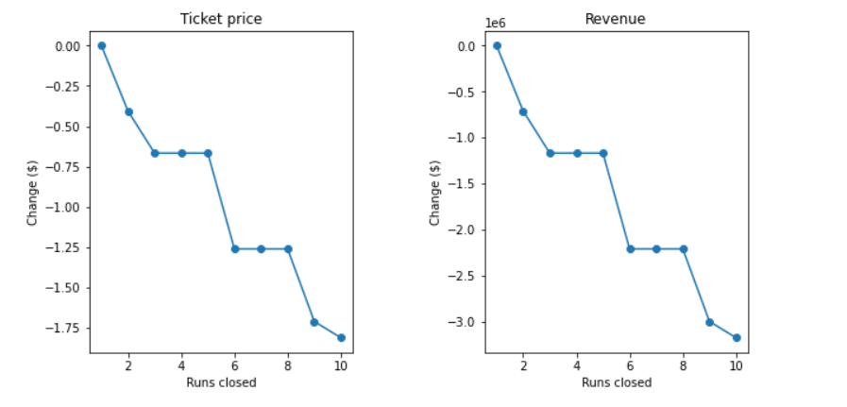

The other promising improvement idea includes adding a run that increases vertical drop by 150ft with and additional chair lift. This shows support for a ticket price increase of $8.61 and could potentially amount to $15M over a season!

In conclusion, our model is a useful tool that can bring insight into future planning and price predictions. Ideally, this tool would be used in conjunction with other considerations and insights from the management team. We feel confident about raising ticket prices to $85.00 and that the presented improvement options are viable. To gain even more insight, the model could be improved to include visitor count data, historical data and cost information. Our team is prepared to dive further into these topics or move into app development with the current our model. We are excited to see how this can support our management team and continue to show that Big Mountain Resort is the best in Montana!